加拿大亞伯達省ICT產業介紹
亞伯達省駐台辦事處陳麗安代表
亞伯達省概況
•卓越的經濟成就
在過去二十年中，亞伯達省每年的平均經濟增長率為3.3%，是加拿大最高的省份。專家預測，亞伯達省的經濟保持這種勢頭發展將繼續成為加拿大經濟表現最好的經濟體之一。亞伯達省的人均投資額一直是加拿大最高的省份。2009年，亞伯達省的人均投資額為18,024加元，幾乎是加拿大人均投資額的兩倍。2009年，亞伯達省的投資總額達到660億加元。 2009年，亞伯達省的失業率為6.6%，遠低於加拿大平均失業率8.3%的水平。

•快速進入市場
亞伯達省位於加拿大的西部地區，這一經濟增長迅速，擁有一千萬人口市場的戰略中心位置。亞伯達省是加拿大西部省份中唯一可以提供到所有加拿大西部和美國太平洋西北部地區的隔夜或二十四小內貨物送達服務，該市場擁有五千萬消費人群。
現代和高效的基礎設施，為迎接下一輪的經濟快速增長，亞伯達省制定了為期三年，總額為201億加元的用於基礎建設投資的資金計劃。

•致力於研發
研發在亞伯達省的經濟中發揮了重要的作用。亞伯達省用於研究的基礎設施包括完善的公用、私人和教育互聯網絡，而且卡加立和艾德蒙頓都擁有眾多傑出開發先進技術的研究科技園區。亞伯達省還擁有眾多面向商界的項目，包括能獲得資金和技術商業化支援等援助的項目。Alberta Innovates 項目依託於亞伯達省在健康、能源和環境、技術和生物領域的優勢。這五個擁有活力的優勢領域為商業提供更高水準的傑出研究成果和理念。這意味著創造產品、服務和工藝不但是應對亞伯達和全球們所面臨的挑戰，而且教育和培訓滿足亞伯達省所需的二十一世紀的人力資源。
Alberta Innovates - Technology Futures (AITF)通過能力建設和研發援助項目幫助科技行業尋找解決方案、開發產品和將技術市場化。它從亞伯達省政府獲得了10億加元的資金援助。
亞伯達省的科學研究和試驗發展(SR&ED)稅收抵免計劃可幫助公司減免10%上限為400萬加元的研發費用，即最多可獲得四十萬加元減免，這些減免款都可以退還給公司，而且適用於所有公司。亞伯達省企業公司(Alberta Enterprise Corporation)鼓勵風險投資。它已獲得1億加元的資金共同投資於亞伯達省優先發展領域的早期資本金。
加拿大國家奈米技術研究院(NINT)是世界上技術最領先的研究機構之一，位於亞伯達大學校園內，耗資1.2億加元。該院的主要研究領域側重於奈米器件和材料集成于複雜奈米系統中，並將其投入實用。

•熟練和高效的勞動力
2009年，亞伯達省63.2%的25歲以上的勞動力擁有大學學位或專上畢業文憑或証書。2009年，亞伯達省勞動力參與率是加拿大最高的省份，達到74.3%，比加拿大平均水平高7%。同時，亞伯達省的就業率也是加拿大最高的省份，達到69.4%。
亞伯達省的資通訊(ICT)產業：
亞伯達省擁有強大、技術力量雄厚和不斷增長的資通訊(ICT)產業，其創新能力世界聞名。亞伯達省強勁的ICT產業的繁榮促進了所有經濟領域的增長。穩固的ICT產業包括將近4,300家公司和54,500名雇員，年收入超過102億加元，是亞伯達省第三大增值產業。

資通訊(ICT)產業類別：
亞伯達省的資通訊(ICT)產業擁有眾多世界級公司，擁有各種商業領域的專業知識，其中包括：
• 生物資訊 • 奈米技術
• 數位內容 • 軟體開發
• 數位學習 • 系統整合
• 衛星定位系統 • 通訊
• 健康管理系統 • 無線通訊

專業領域
亞伯達省的資通訊(ICT)產業擁有高素質的人力資源、先進的基礎設施和超群的研究中心為投資者提供了絕佳的投資環境。
眾多技術方面的合作和投資前景支援亞伯達省優先發展的能源、環境、健康醫療和教育等行業的發展。亞伯達省政府可以為 貴公司提供與亞伯達省資通訊(ICT)產業相關的潛在合作和投資機遇的聯繫方式和資訊，包括以下領域：
• 數位媒體：學習亞伯達省的數位媒體產業如何在網站設計和開發、行動裝置應用、電子遊戲、互動娛樂和社群媒體應用等領域創造機會。
• 奈米技術和微系統：奈米技術對亞伯達省的經濟具有重大影響。讓我們研究亞伯達省如何成為加拿大的奈米技術和微系統研發中心。
• 軟體和IT技術：開發亞伯達省在軟體和IT技術領域中從企業和工業過程控制的解決方案到影像處理和通訊等方面的商業和教育機遇。
• 無線技術：瞭解亞伯達省的無線技術產業，以及在地理資訊學、遙感技術、嵌入式系統和無線寬頻領域的商機。

Alberta Innovates
通過 Alberta Innovates，商業機構、政府和高等教育機構可以共用資源、專業人才和想法。用戶可以獲得獨一無二的資源，包括各領域頂尖的專家、可節省數百萬資金和數年開發時間的基礎設施、及地球上絕無僅有的自然資源。所有資源向研究和商業合作夥伴開放。盡管 Alberta Innovates 還是一個新系統，但是它集合了數十年來的研究成果和世界公認的開創性研究發現。而且，它背後還凝聚數十億加幣捐助資金的長期支持。亞伯達省已經吸引了眾多世界上最大型和最成功企業和研究機構進駐，這些機構包括General Electric, Johnson & Johnson, 3M, Bose, Dow Agro, Hitachi, HP, IBM, RIM, Roche, Viterra, Xerox和李嘉誠基金會。

- 關鍵字：每篇文章請勾選有下列那些關鍵字，請打勾，並放在文章結尾最下方
A組：□智慧生活、□通訊、□資訊、□通信、□優質生活、□寬頻、
□光纖、□WIMAX、□無線、□網路。

B組：□安全監控、□聯網電視、□電子書、□數位看板、□智慧建築、
□i236、□節能、□減碳。

加拿大亞伯達省資通訊產業介紹-2
亞伯達省駐台辦事處陳麗安代表
亞伯達省資通訊協會是一個產業主導、非營利組織，旨在扶持和培育亞伯達省資通訊領域的公司。該協會負責協調資通訊產業各利益相關者之間的關系，合理調配資源以確保商業化進程有效進行。該協會主要從事以下工作：
產業聯合：聯合產業內組織開拓商機和解決商業障礙，相關工作內容包括調配項目和可用資源以滿足亞伯達省資通訊技術產業更廣泛的需求，確保其在加拿大和國際市場的地位。
有效融資：創造亞伯達省資通訊技術公司能獲得開發、商業化和全球化的資金保障，為其產品和服務引航保駕。相關工作內容包括鑒別投資障礙、改善投資者認知、加強商業計劃和提高企業家技能。
進入市場：支援亞伯達省資通訊公司的產品進入加拿大國內和國際市場，通過贊助協同營銷活動、協調展開出口開發培訓和主辦產業相關者活動等措施幫助亞伯達省資通訊公司識別新的市場機會。

勞動力和技能：通過加強與產業內和教育機構之間的關系、提高專業人才可用度，吸引人才進入亞伯達省資通訊領域，技能、贊助創造就業機會的項目、協調顧問團隊、主辦技術和創新研討會和建立企業家商業網絡等措施提高亞伯達省資訊通信技術產業的勞動技能。
產業認知：為改善亞伯達省資通訊產業的認知能力創造條件和建立關系，相關工作內容包括收集產業數據、編制統計數據和產業產能報告。

相關網站：
– 加拿大亞伯達省 www.albertacanada.com
行業公協會組織：
– Alberta ICT Council www.albertaict.ca
– Digital Alberta www.digitalalberta.com
– BioAlberta www.bioalberta.com
– Alberta Council of Technologies www.abctech.ca
– Infoport www.infoport.ca
研發單位：
– Banff New Media Institute www.banffcentre.ca
– National Institute of Nanotechnology www.nrc-cnrc.gc.ca/eng/ibp/nint.html
– Innovate Calgary www.innovatecalgary.ca
– TEC Edmonton www.tecedmonton.com
– Alberta Innovates www.albertainnovates.ca
亞伯達省資通訊技術協會：
www.albertaict.ca，Mr. Patrick Binns, Executive Director，Suite 443, 3553-31st Street NW
Calgary, Alberta, Canada T2L 2K7
Tel: +1 780 695-0790；patrick.binns.@albertaict.ca

--資通訊公司介紹
1、Cooll T Systems ：
多年來，CoolIT一直與電腦業研究及設計方面的領導人合作，提供顧客價格合理的新型冷卻產品，讓使用者擁有全方位的解決方案同時又能超出OEM的高標準。這項精心設計並享有專利的科技發揮個人電腦全部的潛能，提供卓越的冷卻性能，同時減少系統噪音並改善重要元件的可靠性。這部小巧但強大的產品已經預先組裝完成，可以輕易的安裝在任何標準規格外殼上。CoolIT的技術皆已運用於全球知名的高效能電腦公司,包括戴爾、Alienware、Velocity Micro、MAINGEAR、Hypersonic、Biohazard、Ultra、Ultraforce、Systemax、 BFG、Commodore Gaming、War Machine及 Shuttle等。
CoolIT已經發表超過37項專利，是供應電子冷卻產品的世界先驅，在利用我們專利的科技設計、開發及製造水冷系統上，我們擁有卓越的信譽。我們創新的產品超越嚴苛的性能要求並提供我們的顧客實在的價值。為了提供顧客世界級的產品，我們經驗豐富的工程團隊有全套的實驗室與測試設施，包括最新的設計與分析軟體及硬體。
Company Description:
For years, CoolIT has been working with leaders in the computer industry to research, design, and provide an affordable new cooling product that provides a comprehensive solution for end users while exceeding high OEM standards. This carefully designed and patented technology unleashes the full potential of a PC, providing superior cooling performance while reducing system level noise and improving reliability of vital components. This small, but potent, pre-assembled product can also be easily installed inside any standard chassis. The CoolIT technology can be found in the top names in performance computing like Dell, Alienware, Velocity Micro, MAINGEAR, Hypersonic, Biohazard, Ultra, Ultraforce, Systemax, BFG, Commodore Gaming, War Machine and Shuttle.

With over 37 issued patents, CoolIT Systems is a world leader in supplying electronics cooling products, with an excellent reputation in the design, development, and manufacturing of liquid cooling systems using our patented based technology. Our innovative products exceed strenuous performance requirements and provide solid value to our customers. To provide our customers with world-class products, our highly experienced engineering team offers complete lab and testing facilities including the latest design and analysis software and hardware.
3920 29th Street NE，Calgary, AB T1Y 6B6
Toll-free: 1-866-621-COOL (2665)；www.coolITsystems.com

Product Description:

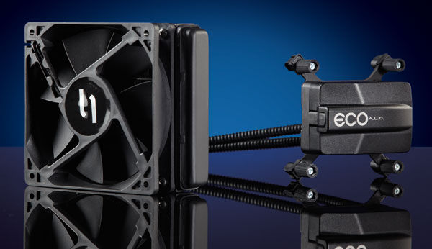
CoolIT specializes in providing innovative liquid cooling solutions for both CPUs and GPUs. Utilizing high performance radiators, these systems are able to use low fan speeds in order to increase efficiency and minimize acoustic noise. Unlike conventional liquid-cooling setups, CoolIT systems are pre-filled and factory sealed, making them easy to install and maintenance-free. Further, their compact designs contribute less stress on the motherboard than air-cooling alternatives.

CoolIT’s OMNI ALC, represents an industry first: it is a fully upgradeable, factory-sealed, liquid-cooled video card solution. With this system, new video cards do not require entirely different cooling solutions; only the interposer plate must be changed. This enables the system to survive beyond just one generation of VGA technology, and keeps the total cost of ownership as low as possible. It also helps to make one of the most environmentally friendly products in the marketplace.

In addition to retail products, CoolIT also offers a large number of OEM services. They have a diverse range of proprietary products including electronic cooling systems, data center cooling systems, DC and AC axial fans, as well as DC blowers for industrial and commercial applications. CoolIT also excels at providing custom turnkey solutions and has the infrastructure to support design and engineering, prototyping and manufacturing, as well as system testing and validation.
Keywords: energy saving, intelligent life, quality of life

2、Eleven Engineering ：
Eleven Engineering 公司是一家總部位於加拿大艾德蒙頓的無晶圓半導體公司。我司為設計人員、開發人員和製造商提供可信賴的、可投入大批量生產的無線音頻模組和系統級封裝產品 SiPs (“System in Package”)。Eleven Engineering 公司將展示其獲獎的 SKAA 個人無線音頻標準。SKAA是 Eleven Engineering 公司為攜帶型設備制定的無線音頻標準。
SKAATM使大量無線音頻附件可以嵌入到行動電話、媒體播放器、筆記型電腦、Netbook和平板電腦中。在SKAA標準中，音源通常來自攜帶型設備，但是通過無線連接的附件幾乎可以是數百種形式和多點配置，如：揚聲器、所有種類的耳機、家庭劇院系統、條形音箱、超低音音箱和汽車音頻系統等。與SKAA標準相容的產品已經在市場上零售，許多消費性電子產品公司都正在開發與SKAA標準相容的產品。
SKAA標準平台還有以下特點：
100%的夥伴品牌互操作性、 低功耗、低延遲、 高聲音保真度、可以實現與最多四個獨立接收節點結合，從而實現真實身歷聲和無線超低音音箱的配置以及多用戶的社交互動。
10150 - 100 Street, Suite 900，Edmonton, Alberta, Canada, T5J 0P6
Tel: +1 780 425 6511，Fax: +1 780 425 7006；www.elevenengineering.com
Company description :
Eleven Engineering is a fabless semi-conductor company headquartered in Edmonton, Canada, whose product lines provide designers, developers, and manufacturers with rocksolid, mass-production-ready modules and SiPs (“System in Package”) for a wide range of wireless audio applications.
Eleven will be demonstrating their award–winning SKAA Personal Wireless Audio Standard. SKAA is the wireless audio standard for portable devices by Eleven Engineering. SKAA™ enables a myriad of wireless audio accessories for mobile phones, media players, notebooks, netbooks and tablets. With SKAA, the source of audio is always a portable device, but the wirelessly-connected accessory can be… virtually ANYTHING—speakers in hundreds of styles and multipoint configurations, all types of headphones, home theatre systems, sound bars, subwoofers and car audio systems to name a few.
SKAA-compatible products are already selling at retail and dozens of consumer electronics companies are currently developing new products with SKAA.
Other features of the SKAA platform include:
- 100% partner brand inter-operability
- Low power consumption
- Low latency
- Excellent fidelity of sound
- An ability to bond to up to 4 separate receiver nodes, thereby enabling true stereo and wireless subwoofer configurations, as well as multi-user social interaction.

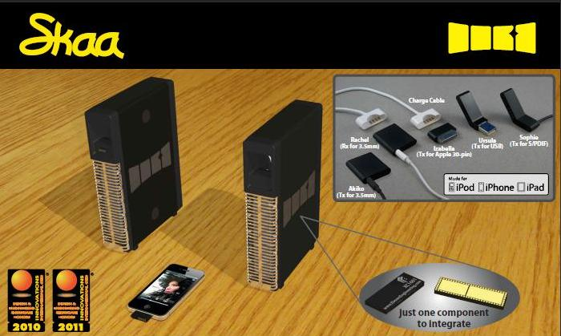
Product Description:
In terms of audio, Eleven Engineering offers a wide variety of products to suit many different customers. Their home theatre series is the world’s most trusted digital wireless solution, and it allows the coexistence of both 2.4GHz and 5.8GHz bands with a range of up to 25 meters. Eleven Engineering also offers multi-room audio systems that support up to 8 receivers and have a range of 50 meters.
Professional and semi professional audio systems offered by Eleven Engineering include a bidirectional data channel that enables two way control options on guitars and microphones that were never possible with analog. Karaoke applications are also available that support 2 microphones to 1 receiver and offer long battery life. Low RF power output enables multiple Karaoke system to coexist in commercial applications such as Karaoke restaurants.
In addition to wireless audio, Eleven Engineering offers wireless Ethernet based on a 1.536 Mbps link. Available in 900MHz and 5.8GHz models, these systems can have a range of up to 30 miles for direct line-of-sight and are ideal for wireless LAN extension, video surveillance, as well as wireless telemetry. Eleven engineering also offers general purpose wireless modules that can be adapted to suit a range of needs: wireless video game control, wireless digital HiFi audio, medical telemetry, and industrial monitoring. These devices are all equipped with the XInC processors.
XInC™ (pronounced "zinc") is a 16-bit pipelined RISC processor with 8 hardware threads. The 8 threads behave as 8 independent processors, each with unrestricted access to main memory and the peripheral bus. Additionally, the threads share hardware resources with the exception of each thread's dedicated register set. This approach results in outstanding MIPS/gate efficiency. The reduced efficiency of serial interrupt-based processors caused by context swapping, task scheduling, unpredictable execution times, and RTOS overheads is avoided by the XInC architecture.
Each thread is scheduled to execute at 1/8 of the system clock, thus removing the overhead of an RTOS (Real-Time Operating System). Code is written as 8 individual programs, each running on its own thread and may be used to service one or more I/O peripherals. In a typical wireless application 3 threads might be used to execute a wireless protocol, while the other 5 threads are made available to run other programs. XInC is available in packaged chip, bare die, and core IP forms.
Keywords: Intelligent life, communication, quality of life, security/monitoring, energy saving, wireless, network

3、Kanata Health Solutions Inc：
Kanata Health Solutions Inc. 正帶來一套全新、突破性的無線個人監視系統，將解決市場多年來的難題。經過五年的開發，我們的科技發展夥伴包括亞伯達大學(University of Alberta)、精工精密株式會社(Seiko Instruments International)、, MI Labs (Sony)。我們的臨床夥伴包括加拿大最大的整合式醫療保健業者Alberta Health Services，也就是過去知名的Capital Health Authority(加拿大艾德蒙頓)。

我們看到機會去開發一個合乎成本效益的辦法，把它應用在整個照護產業；創造策略性的機會減少照護成本同時改善臨床結果。讓個人更自足並主動管理自己的疾病或健康，Kanata Health的監視系統減少比較耗費成本的治療方式，包括長時間的住院或在有人協助的生活或長期照護機構內繼續接受照護。Kanata Health的監視系統目的在於減少家人或親友照顧病人的負擔，同時提供持續的照護，讓生病或年長的人可以在家裡得到安全的保障。
10205 111 Street ，Edmonton, AB T5K 2V6；Canadawww.kanatahealth.ca
Company Description:
Kanata Health Solutions Inc. is bringing a new, breakthrough wireless personal monitoring solution to market. Developed over the past 5 years, our technology development partners have included the University of Alberta, Seiko Instruments International, MI Labs (Sony). Our clinical partners include Canada’s largest integrated health care provider, Alberta Health Services, previously known the Capital Health Authority (Edmonton, Canada).

We have recognized the opportunity to develop a cost-effective solution that applies across the continuum of care; creating strategic opportunities to reduce the cost of care while improving clinical outcomes. By empowering individuals to become more self-sufficient and proactive in managing their own illness or wellness, Kanata Health’s monitoring solution reduces the need for more costly treatment alternatives, which can include lengthy hospital stays or continuing care within assisted living or long-term care facilities. Kanata Health’s monitoring solution aims to reduce the burden on individuals in the care of family members or friends while providing continuous care, which allows the ill or elderly to remain safely and securely in their homes for a greater portion of their life.


Product Description:
The company is taking to market 7 years of R&D (the Wireless Wearable Physiological Monitor (WWPM)) project managed at the University of Alberta. This project was designed to develop new physiological sensors for integration into health monitoring, health promotion and illness prevention. The University also coordinated the assembly of a cluster of multi-national and Alberta companies for the purposes of:
- Development of new physiological sensors, software and hardware solutions to overcome, mobility, distance, and determine the frequency of physiological data collection from active humans and animals.
- Combining their complementary technologies and expertise into integrated e-Health solutions for humans and animals,
- Creating a new spin-off company from the University of Alberta to develop and commercialize e-Health software and system solutions,
- Establishing two demonstration sites in Alberta (one each for humans and animals),
- Define data management requirements for individuals and organizations, such as monitoring stations,
- Setting the stage for subsequent co-commercialization of e-Health solutions by the participating organizations from an Edmonton-based location.
Keywords: Information, wireless, intelligent building, quality of life, intelligent life

4、PanasourceCanada Corp
38DDnet是設立於加拿大亞伯達省卡加立市的Panasource Canada公司一個全新的無線產品牌。我們新的超級迷你802.11N無線路由器(Wireless Router)將是世界上最小的路由器之一。輕薄短小並附帶正在申請專利的特製RJ45連接器。可免費下載Iphone/Ipad/Ipod touch以及Android等產品所需的配置軟體。
38DDnet無線產品提供世界一流的設計，無論是在硬體和軟體的使用上都十分簡易。38DDnet也提供符合北美標準的最好支持和服務。除了開發產品的卓越能力之外，我們在品牌行銷上也有非常優異的表現，缺乏優秀行銷手段的支撐，再好的產品也很難在市場佔有率上有傑出的表現。38DDnet無線產品也與全球的經銷商，重新創造一個包括利潤分享的長期合作夥伴關係。我們只考慮優秀的經銷商。沒有經銷商為我們的客戶提供優質的服務，我們將不會讓產品大量地在市場上流通。
我們正在尋找經銷商與我們合作，有興趣的經銷商請與我們聯繫：請聯繫Darrell Hui先生，sales@38ddnet.com
608, 300 Meredith Road N.E.，Alberta, Canada. T2E 7A8
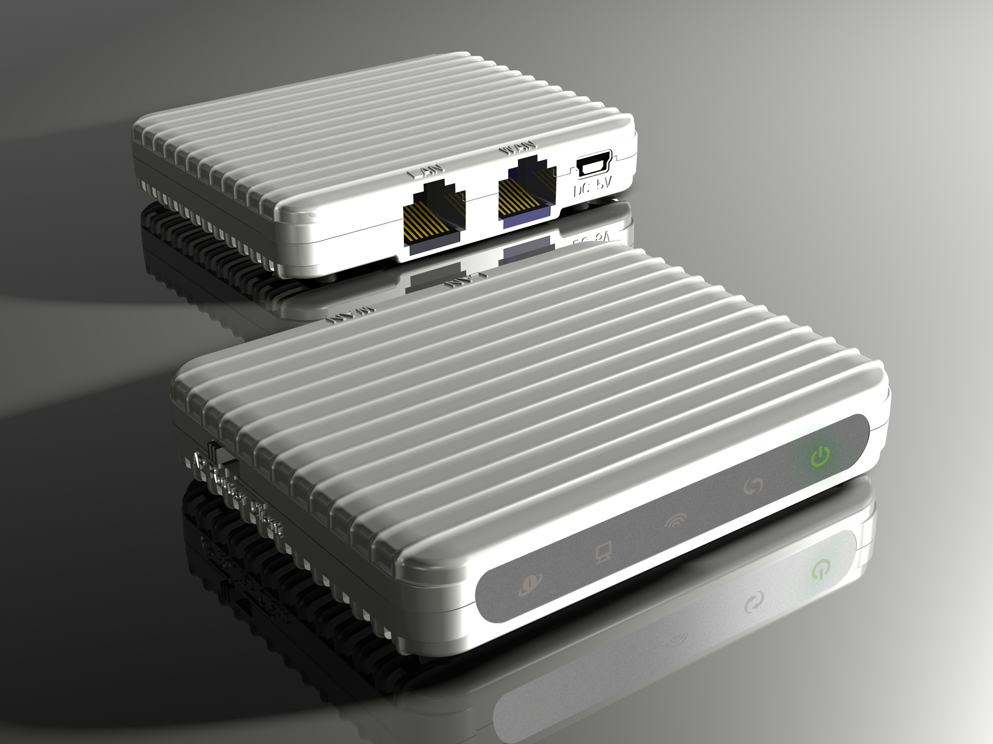
TEL: 1-403-272-3838；www.38ddnet.com
Company Description:
38DDnet is a “brand” new wireless product of Panasource CanadaCorp. that is based in Calgary, Alberta, Canada. Our new Super Mini 802.11N Wireless Router” will be one of the smallest routers in the world. Thin and tiny size and a special RJ45 connector that is patent pending provide configuration software for Iphone/Ipad/Ipod touch and Android for free download
38DDnet wireless products offer the world class designs both in the hardware and software for easy to use. 38DDnet also offer one of the best supports and services base on North American Standard. Beside our excellent in products development, we are also excellent in BRAND marketing, without good marketing support, this will be hard for a good product to have excellent market share.
38DDnet wireless products also re-create a long term partnership with the worldwide dealers that included profit sharing.
We are looking for very limited dealership to work with us. We are only looking for Quality dealers. We will not flood the markets with our products without the dealer offer good support to our customers.
Interested dealers please contact Mr. Darrell Hui at sales@38ddnet.com
Keywords: Wireless, communication, network
5、Qsound Labs, Inc
QSound Labs Inc.是行動裝置、電視、個人電腦多媒體及其他消費性電子產品影音軟體科技的領導品牌。QSound軟體解決方案及科技包括：
遊戲、音樂及電影的3D音頻解決方案；音效庫，例如EQ、DRC、抗飽和；鈴聲錄放MIDI合成器；減少雜音及消除回音。
QSound軟體解決方案已經應用在一億多支行動電話上，包括LGE、Panasonic、 Pantech、Samsung & ZTE等公司的產品。 此外，QSound解決方案目前正應用在Toshiba液晶電視，VIA Technology的個人電腦音效晶片並作為RealNetworks RealPlayer隨插隨用的配件。這一切科技都可以授權客製化套裝軟體以符合特定的應用程式需要。
#102, 2816 - 11 St NE，Calgary, Alberta，Canada T2E 7S7
Tel: +1 403.291.2492，Fax: +1 403.250.1521；Email: www.qsound.com/
Company Description:
Qsound Labs, Inc. is a leading supplier of audio and voice software technology for mobile devices, televisions, PC multimedia and other consumer electronics. QSound’s software solutions and technologies include:
- 3D audio solutions for games music and movies
- Audio effects library e.g. EQ, DRC, Anti-saturation
- MIDI synthesizer for ringtone playback
- Noise Reduction and Acoustic Echo Cancellation
QSound’s software solutions have shipped in over 100 million mobile phones including products from LGE, Panasonic, Pantech, Samsung & ZTE. Additionally, QSound solutions are currently shipping in Toshiba LCD TVs, VIA Technology PC sound chips and as a plug-in for RealNetworks RealPlayer. All of this technology is available for licensing in custom packages designed to meet specific application needs.

Product Description:


Qsound offers a number of compact, high performance software digital audio engines for modbile devices. These enable polyphonic ringtones, 3D game sound, and multi-format audio playback with performance levels that greatly surpass industry benchmarks.
For PCs and Cars, Qsound offers solutions that render high-quality, multi-channel virtual surround audio with maximum spatial impact over stereo headphones, stereo speakers and multi-speaker surround systems, creating a powerfully immersive listening experience. Qsound also has a long history in 3D video game audio, and their Q3D process accepts multiple monophonic audio streams and applies a desired location in three-dimensional space. Positioned streams are mixed together and sent to a common stereo or multi-channel output. They also offer the Q3D-Graphics: a fast and efficient standards-based 3D graphics solution available for mobile devices supporting Windows Mobile, BREW and iPhone platforms.

The QXpander® QX2020 is an analog stereo enhancement processor. This device is part of the QX chip family offered by QSound Labs, and uses the patented QXpander technique to produce a spatial or widened stereo image from ordinary left and right channel inputs. QXpander® is a stereo to 3D enhancement process and is a trademark of QSound Labs.

Keywords: Quality of life, wireless, intelligent life, communication

6、Taylor Scheduling Software
Taylor自1989年起便一直開發並行銷高階規劃及製造時程安排系統(生產時程安排，限定產能時程安排)。在這段期間，我們針對下列複合式工業為世界各地超過八十家製造商順利安裝軟體：航太零件，汽車零件，批次化學，營造，連接器，LED，材料，消費性包裝品，化妝品，消費性電子產品，食品及飲料，加工車間，包裝，製藥，PCB，塑膠，紡織。
我們開發並行銷高階規劃及生產時程安排(APS)軟體給全世界的製造商。此外，我們不斷提供諮詢與支援服務，包括流程模式，新型應用程式開發，客製化報告及整合其他各種系統(ERP, CRM, MRP, MES)。Taylor了解您在製造方面所面臨的挑戰，也知道您的公司與工廠所面臨的是與眾不同的問題。我們提供您需要的時程安排及優化工具來對付這些困難—Taylor時程安排軟體考量您特有的問題，幫助您做出對的決定以符合您的目標。Taylor軟體產品配合您現有的製造規劃及盤存管理系統(企業資源規劃(ERP)，供應鏈管理(SCM)等等)。Taylor軟體產品提供彈性的時程安排、管理及決策支援工具以符合您的需要，這些軟體都可透過微調來解決您安排製造時程時所面臨的問題。每套系統都可以配合您的業務與流程來調整，而不是改變您的設備運作方式來配合規劃及時程安排系統。
10230 - Jasper Avenue, #4350，Edmonton, Alberta，Canada T5K 2J1
Ph: (780) 414-6718 Ext 223，Fax: (780) 414-6716；www.taylor.com
Company Description:
Taylor has been developing and marketing advanced planning and manufacturing scheduling systems (production scheduling, finite capacity scheduling) since 1989. During that time, we have successfully implemented software for more than eighty dynamic manufacturers around the world, focusing on the following complex industries:
Aerospace Parts, Automotive Parts, Batch Chemicals, Construction, Connectors, LED, Materials, Consumer Packaged Goods, Cosmetics, Consumer Electronics, Food & Beverage, Job Shop, Packaging, Pharmaceuticals, PCB, Plastics, Textiles
We develop and market Advanced Planning and Production Scheduling (APS) software for manufacturers around the world. In addition, we provide ongoing consulting and support services, including process modeling, new application development, custom reports and integration with a variety of other systems (ERP, CRM, MRP, MES).
Taylor software products meet your needs by providing flexible scheduling, management and decision support tools that can be fine-tuned to solve your manufacturing scheduling problems. Each system can be adjusted to suit your business and processes, rather than change the way your facility functions to suit your planning and scheduling solution.
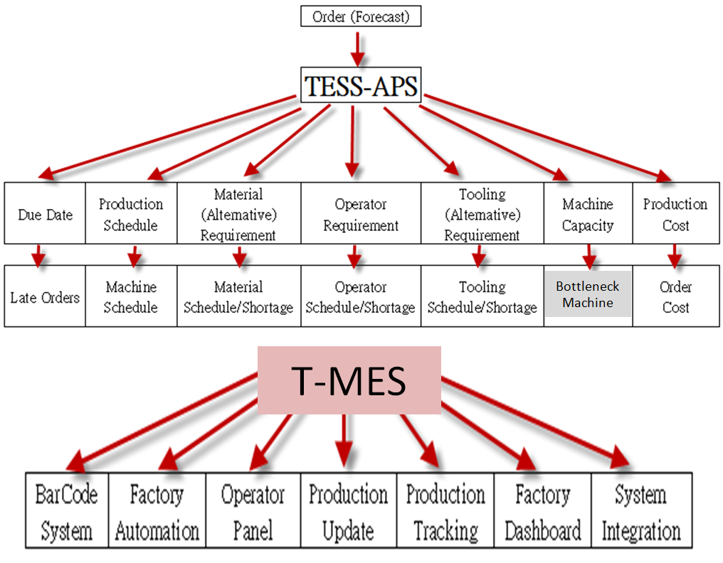
Product Description:
Taylor understands your manufacturing challenges and realizes you face problems unique to your company and your plants. We provide the scheduling and optimization tools you require to combat these difficulties: Taylor Scheduler, Capacity Planner, Decision One, and TS Event Planner.
Taylor Scheduler helps you make the right decisions to meet your objectives, taking into account your unique problems. Taylor software products work with your existing manufacturing planning and inventory management systems (Enterprise Resource Planning (ERP), Supply Chain Management (SCM), etc.).
Capacity Planner allows you to identify capacity obstacles, evaluate alternatives and then implement solutions, or if you prefer, Capacity Planner can automatically solve many of these problems without your intervention. Planners can then focus on using their expertise to address other pressing issues.
Decision One is designed to solve scheduling problems in small to medium manufacturing environments. Decision One is an inexpensive scheduling program that delivers a quick and accurate schedule. Decision One is designed so that you can also import your data from Microsoft Excel® into Decision One and schedule actively with drag-and-drop functionality
Taylor's TS Event Viewer uses an intuitive calendar format to display selected information about the current production schedule. As the production schedule is updated, so is the TS Event Viewer, providing your staff with up-to-the-minute information they need to do their work more efficiently.
7、Userful Corp
Userful以環保的桌上型電腦連接世界。Userful公司是全世界Linux桌面虛擬化的先驅公司，在全球100多個國家擁有數百萬用戶。本公司的軟體可以將一台電腦變成10台電腦，並只需一個簡單的管理網站即可管理該電腦組。此舉不僅減少桌上型電腦的成本、提高可管理性，並降低了電力消耗和電子廢棄物。Userful軟體係通過全球的轉銷商網絡合作夥伴和OEM來進行銷售。Userful軟體目前擁有超過75萬個銷售點，已廣泛被學校、圖書館、飯店、網咖、客服中心、油田產業、軍事方面等所使用。Userful是一家成立於1999年的私人公司。
Userful的核心產品；Userful MultiSeat Linux 2011™是一套完整的課堂電腦軟體，只需連接額外的顯示器、鍵盤和滑鼠，即可將一台Linux電腦主機變成10台獨立的高性能電腦。這套軟體已經應用在全球超過五萬所學校內，讓學校能夠以極低的成本，快速地擴充桌上型電腦工作站，無論是在教室、電腦實驗室或學校圖書館。Userful MultiSeat也提供專為其他行業多用戶所設計的獨立套件。Userful Desktop™是一套完整的電腦解決方案，可提供管理、監督和快速擴充您的電腦。它提供的安全、可靠和無病毒裝置，解決公共電腦的一切問題，並包括支援超過30種語言的40種應用程序。簡單的遠程管理能輕易地控制和客製化電腦，節省時間和金錢。
200-709 11th Ave. SW，Calgary, Alberta T2R 0E3 CANADA
Tel: +1.403.289.2177 ，Fax: +1.403.206.7010
Email: info@userful.com ；www.userful.com
Company Description:
Userful is connecting the world through sustainable desktop computing.Userful Corporation is the world's leading Linux desktop virtualization company with millions of users in over 100 countries. The company's software which turns 1 computer into 10 and manages fleets of computers through a simple admin web site, lowers desktop computing costs, improves manageability, and reduces both electricity consumption and e-waste. Userful's software is sold through a partner network of resellers and OEMs worldwide. With over 750,000 stations sold, Userful software is used by schools, libraries, hotels, Internet cafes, call centers, oil fields, military and more. Userful is privately held and was founded in 1999.
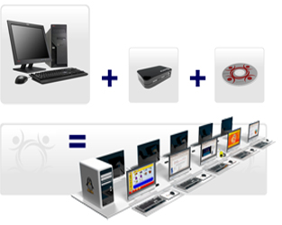
Product Description:
Userful MultiSeat Linux 2011™ is a complete classroom computer software bundle that turns 1 Linux computer into 10 high performance independent computer stations by simply attaching extra monitors, keyboards and mice. Already used in over 50,000 schools worldwide, it enables schools to quickly deploy large numbers of computer stations for a very low cost, whether in the classroom, computer lab, or school library. Userful MultiSeat is also available as a stand alone package to multi-user enable computers for other industries.
Userful Desktop™ is a complete public computing solution that lets you manage, monitor, and multiply your PCs. It takes the headache out of public computing by providing a safe, secure and virus-free setting for clients that includes over 40 applications supporting over 30 languages. Simple remote management makes it easy to control and customize PCs, saving time and money.

